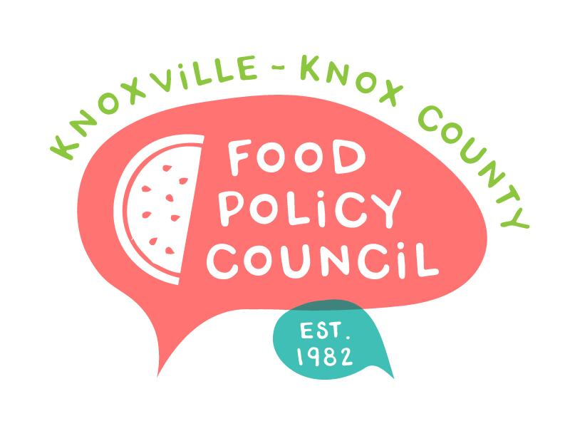
Knoxville-Knox County Food Policy Council
Agenda
8:30-10:00 AM
August 19, 2021
United Way of Greater Knoxville

- Welcome, Introductions
- Nominations and Executive Committee Updates
- Bylaws and Nominations Committee Reminders
- Organizational Updates and Announcements
- Networking and Conversation

Masks are required @ the United Way for vaccinated and unvaccinated individuals.

Note: Knoxville Leadership Foundation does operate the KnoxWorx program that includes some food service training with UT’s culinary institute. This is the page where employers can sign up for this program https://knoxworx.klf.org/employer-partners/. They can also directly contact Ryan McDaniel (rmcdaniel@klf.org), the placement coordinator, or Andrew Church (achurch@klf.org), the director.

Mark Your Calendars
September 16 at 8:30 am: Educational Meeting, Topic TBD
October 21: Educational Meeting, ALICE Presentation with Q&A
November 18: Voting Meeting (Bylaws, Nominations, Executive Committee)

