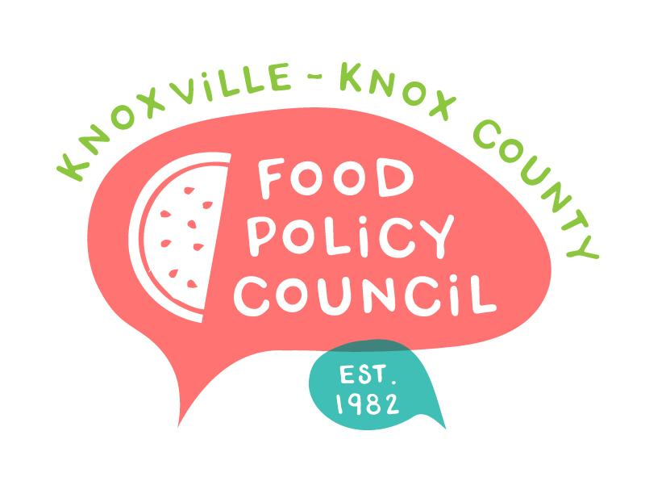
Knoxville-Knox County Food Policy Council
Agenda
8:30-10:00 AM
April 19, 2023
United Way of Greater Knoxville

- Welcome and Introductions: Bailey Foster
- Presentation: Kat Bike from Nourish Knoxville
- Organizational Updates and Announcements: Bailey Foster
- Adjourn

Next Meetings

May 17, 2023
Presentations by Second Harvest, American Heart Association
8:30 – 10 am
United Way of Greater Knoxville

June 21, 2023
Presentation by Russ Jensen from 211
8:30 – 10 am
United Way of Greater Knoxville

