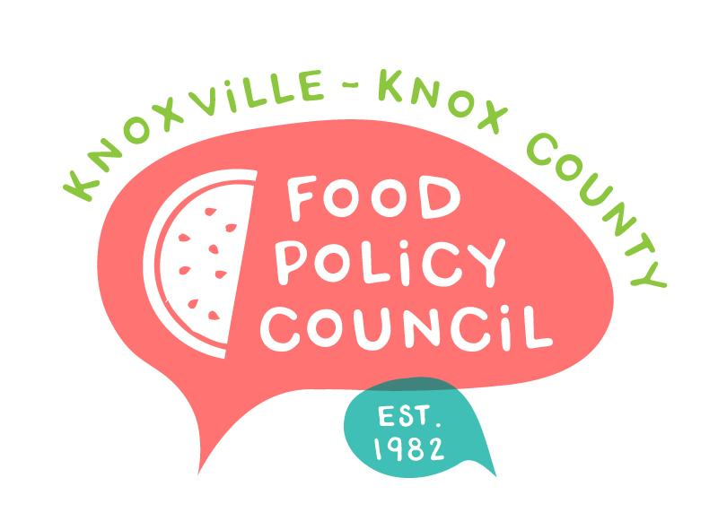
Knoxville-Knox County Food Policy Council
Agenda
8:30-10:00 AM
May 17, 2023
United Way of Greater Knoxville

- Welcome and Introductions: Bailey Foster
- Presentation: Second Harvest Food Bank of East TN
- Presentation: Knoxville-Knox County Planning
- Organizational Updates and Announcements: Bailey Foster
- Adjourn

Next Meetings

June 21, 2023
Presentation by Russ Jensen from 211
8:30 – 10 am
United Way of Greater Knoxville

July 19, 2023
Annual Retreat
Location and Final Details in Planning

