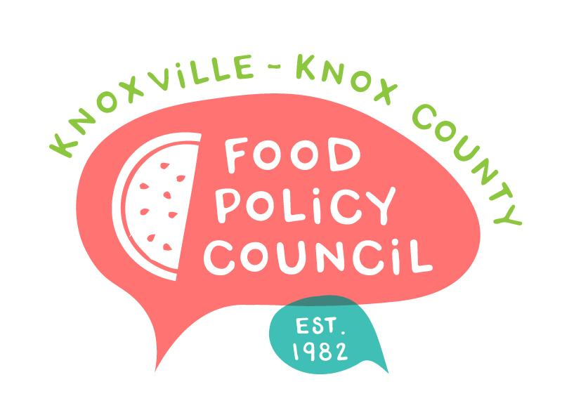
Knoxville-Knox County Food Policy Council
Agenda
8:30-10:00 AM
June 21, 2023
United Way of Greater Knoxville

- Welcome and Introductions: Bailey Foster
- Presentation: Marissa Spady No Kid Hungry
- Organizational Updates and Announcements: Bailey Foster
- Adjourn

Next Meetings

July 19, 2023
Annual Retreat
Location and Final Details in Planning

