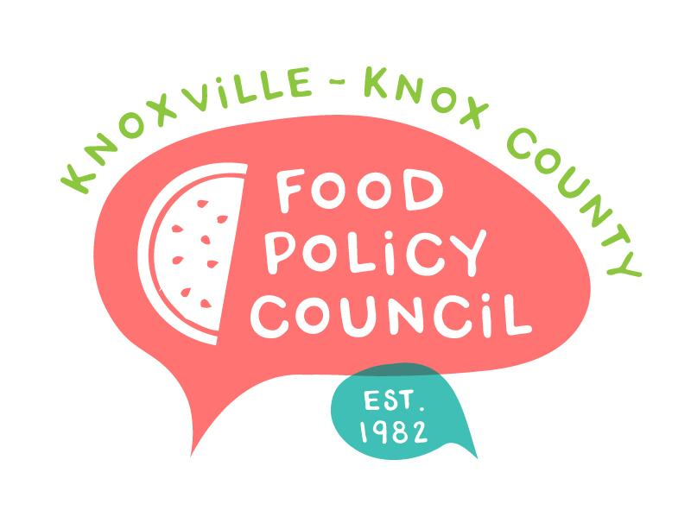
Knoxville-Knox County Food Policy Council
Agenda
8:30-10:00 AM
April 17, 2024
United Way of Greater Knoxville

- 8:30: 9:00: Welcome and Introductions: Bailey Foster
  - Icebreaker: Madelyn Howe
  - December -March Minutes Approval: Bailey Foster
- 9:00 – 9:45
  - Rooting Ourselves Activity: Group work and Share Out
  - Establishing 2024 Committees
  - Nominations and Bylaws
- 9:45 – 10:15: Growing Our Work Presentation: Kimberly and Madelyn
- 10:15 – 10:30: Organizational Updates and Announcements: Bailey Foster

Next Meeting

May 15, 2024
UT Students Market Basket Study
Food Supports for School-aged children: Sandra Wairimu and Imelda Gutierrez
8:30 – 10 am
United Way of Greater Knoxville

