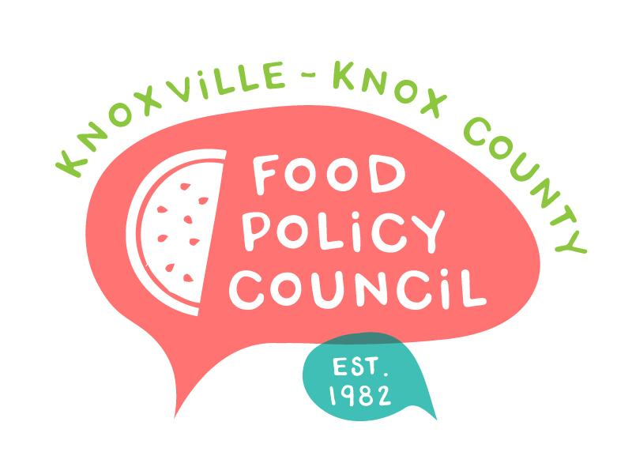
Knoxville-Knox County Food Policy Council
Agenda
8:30-10:00 AM
August 21, 2024
United Way of Greater Knoxville

- 8:30: 8:45: Welcome and Introductions
- 8:45 – 9:45
  - Transforming Western: Marisa Moazen and Lisa Higginbotham
  - Reconnecting Communities: Marisa Moazen
- 9:45 - 10 am: Organizational Updates and Announcements

Next Meeting

September 18, 2024
“How Small Farms Weather the Storm”
Amanda McHale and Jennifer Russomanno
8:30 – 10 am, United Way of Greater Knoxville

October 16, 2024
TBD

October 25, 2024
People’s Food Plan Coalition Launch
9 – 11 am

November 20, 2024
Nominations, Bylaws
2025 Planning
8:30 – 10 am, United Way of Greater Knoxville

