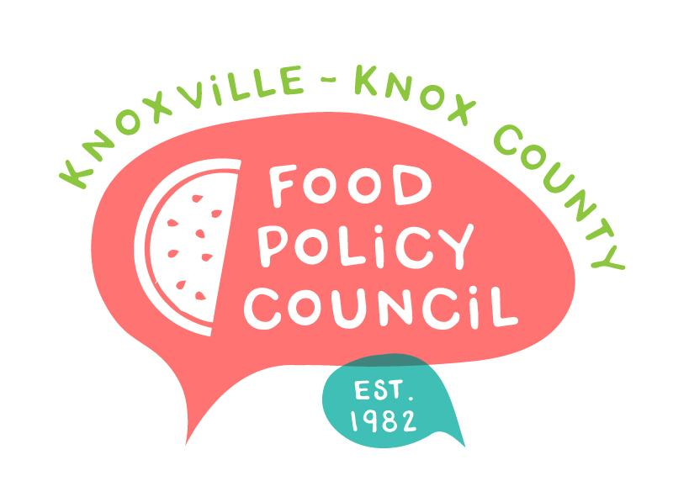
Knoxville-Knox County Food Policy Council
Agenda
8:30-10:00 AM
October 16, 2024
United Way of Greater Knoxville

- 8:30: 8:45: Welcome and Introductions
- 8:45 – 9:45: Youth Homelessness & Mental Health
Jasper McEwan, CAC and John Camp, Knox Pride
- 9:45 - 10 am: Organizational Updates and Announcements
  - Remember next month is a required voting meeting for Bylaws and our nominations slate. We’ll also be planning for 2025.

Next Meeting

October 25, 2024
People’s Food Plan Coalition Launch
9 – 11 am

November 20, 2024
Nominations, Bylaws
2025 Planning
8:30 – 10 am, United Way of Greater Knoxville

December 18, 2024
Holiday Party

