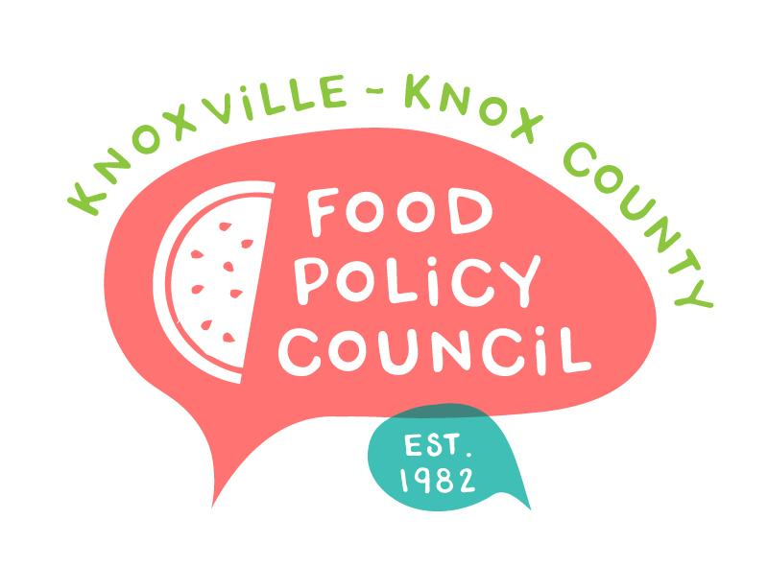
Knoxville-Knox County Food Policy Council Agenda
8:30-10:00 AM
April 16th, 2025

- 8:30: 8:35: Welcome and Introductions: Marisa Moazen
- 8:35 – 8:50: Organizational & Committee Updates
  - 5-minute Check In: Sarah D.
  - Website Updates: Madelyn & Kimberly
  - Council Updates
- 8:50 – 9:00: Presentations Recap: Ariel
- Group Facilitation: Torrie Boggs

Upcoming Meetings

April 22, 2025
Food Distribution Working Group
2:00-3:30 PM
Knox Pride Center

April 25, 2025
HFFI Community Advisory Board
9-11 AM
The Point

May 21, 2025
Food Policy Council Mtg
8:30-10:00 AM
United Way of Greater Knoxville

