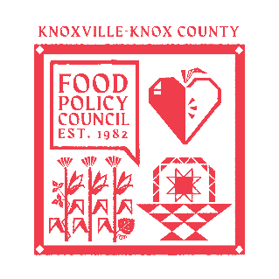
Knoxville-Knox County Food Policy Council Agenda
October 15th, 2025
9:00-1:00 PM
UT Culinary Institute | 2712 Neyland Dr, Knoxville, TN 37916

- 9:00-9:15: Coffee/ Settle In
- 9:15-10 AM: Policy & Advocacy 101 | CJ Butcher- Advocacy and Grants Manager @ The United Way of Greater Knoxville
- 10:00- 11:00 AM: Bold Goal Workshop | Torrie Boggs- Director of Impact @ The Real Good Kitchen Foundation
- 11:00-11:15: Quick Break
- 11:15-12:15
  - Working Lunch | Good Golly Tamale
  - Screen Printing Activity | Ashlee Mays- Executive Director @ Museum of Infinite Outcomes
- 12:15-1:00 PM: Communal Quilt Activity | Chloe Mowry @ Carex Design Group

Upcoming Meetings

Oct 24th, 2025
HFFI Community Advisory Board Meeting
9:00 AM-11:00 AM
Knox Fill

Oct 28th, 2025
Food Distribution Working Group
2:00-3:30 PM
Knox Pride

Nov 19th, 2025
Food Policy Council Mtg
8:30-10:00 AM
United Way of Greater Knoxville

