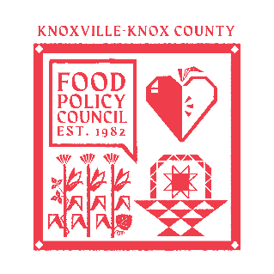
Knoxville-Knox County Food Policy Council Agenda
8:30-10:00 AM
November 19th, 2025

- 8:30- 8:35: Welcome and Introductions: Marisa Moazen
- 8:35 – 9:00: Organizational & Committee Updates
  - By-Law Committee Updates
  - Nominations
  - Council Updates
- 9:00 – 10:00: Bold Goals and Strategies Finalization Session
  - Overview
  - Breakout Groups

Upcoming Meetings

Mondays @ 9 AM
Weekly Food Access Committee Call
Zoom

Nov 25th, 2025
Distribution Working Group
2:00- 3:30 PM
Knox Pride

Dec 17th, 2025
Food Policy Council Holiday Party
8:30-10:00 AM
United Way of Greater Knoxville

