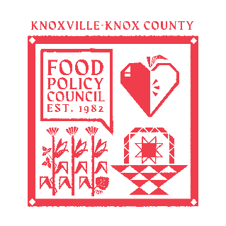
Knoxville-Knox County Food Policy Council Agenda
8:30-10:00 AM
December 17th, 2025

- 8:30- 8:35: Reflection and Introduction: Sarah Dewitt
- 8:35-8:45: Business Updates: Marisa Moazen
  - Minutes Approval
- 8:45 – 9:00: Organizational & Committee Updates: Marisa Moazen
  - Policy Update: New SNAP Waiver Update: CJ Butcher
  - Council Updates
- 9:00 – 10:00: Breakfast and Merriment: Three Rivers Market

Upcoming Meetings

Mondays @ 9 AM
Weekly Food Access Committee Call
Zoom

January 21st @ 8:30
Knoxville Knox County Food Policy Council
United Way of Greater Knoxville

