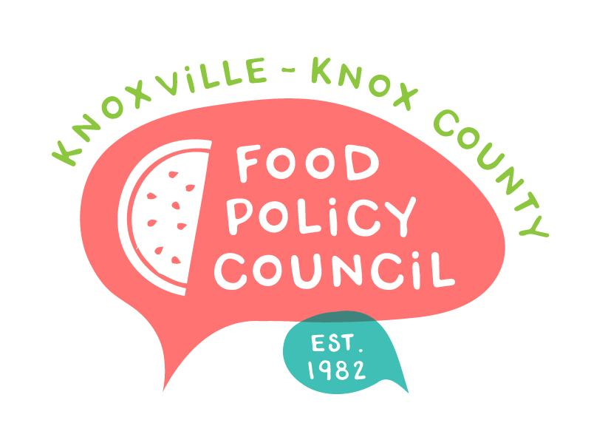
Knoxville-Knox County Food Policy Council Agenda
8:30-10:00 AM
June 18th, 2025

- 8:30- 8:35: Welcome and Introductions: Marisa Moazen
- 8:35 – 9:00: Organizational & Committee Updates
  - Approval of the Minutes
  - FPC Wins: Ariel
  - Council Updates
  - Working Groups: Kimberly
  - Establishing Bylaws & Nominations Committees
- 9:00 – 9:20: FPC Branding Feedback Session: Ashlee Mays
- 9:20- 9:50: FISH Pantry: Jim Wright & Emma Cosigua
- 9:50- 10:00: Dr. Tran Survey

Upcoming Meetings

June 24th, 2025
Distribution Working Group Meeting
2:00 PM-3:30 PM
Knox Pride

June 26th, 2025
Walter Hardy Park Community Share Out
5:00-6:30 PM
Phyllis Wheatley Center

July 16th, 2025
Food Policy Council Mtg
8:30-10:00 AM
United Way of Greater Knoxville

