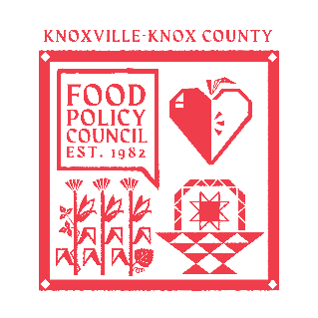
Knoxville-Knox County Food Policy Council Agenda
8:30-10:00 AM
August 20th, 2025

- 8:30- 8:35: Welcome and Introductions: Marisa Moazen
- 8:35 – 9:00: Organizational & Committee Updates
  - FPC Wins: Ariel
  - Bylaws/ Nominations Committees
  - Website Updates
  - One Pager Updates
  - Council Updates
  - September Meeting with Mayor
- 9:00 – 10:00: Working Group Breakouts (Production, Aggregation, Distribution, Consumption, Waste and Recovery)

Upcoming Meetings

Sept 17th, 2025
Food Policy Council Mtg
8:30-10:00 AM
United Way of Greater Knoxville

