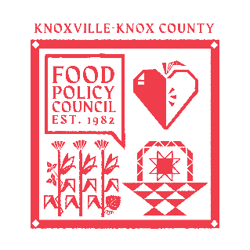
Knoxville-Knox County Food Policy Council Agenda
8:30-10:00 AM
September 17th, 2025

- 8:30- 8:35: Welcome and Introductions: Marisa Moazen
- 8:35 – 9:00: Organizational & Committee Updates
  - FPC Wins
  - Robert Wood Johnson Grant Update
  - Council Updates
- 9:00 – 10:00: Conversation with Mayor Indya Kincannon
  - Brief FPC Overview
  - Kincannon Presentation
  - Questions

Upcoming Meetings

September 23rd, 2025
Distribution Working Group
2:00- 3:30 PM
Knox Pride

Oct 15th, 2025
Food Policy Council Retreat
9:00-1:00 PM
TBD

