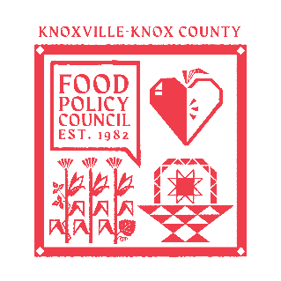
Knoxville-Knox County Food Policy Council Agenda
8:30-10:00 AM
January 21st, 2026

- Centering & Introduction- Sarah
- Reflection - Ariel
  - Highlights and Wins 2025
- Business Updates: Marisa
  - Minutes Approval
- Policy Update/ Opportunities
  - Timeline and Context
  - Current Opportunities
    - County: Unified Development Ordinances Comment
      - Public Meeting via Zoom: 12 pm on Jan 27
    - City: Knoxville Comprehensive Plan

  - Policy Agenda
  - Identify 3 yellow light focuses
  - Policy Subcommittee to focus on research of yellow lights
- Council/Organizational Updates: Marisa

Upcoming Meetings

January 27, 2026
Knox County Unified Development Ordinance Public Input Meeting
12:00 PM
Zoom- Register in advance

February 18, 2026
Food Policy Council
8:30-10:00 AM
United Way of Greater Knoxville

