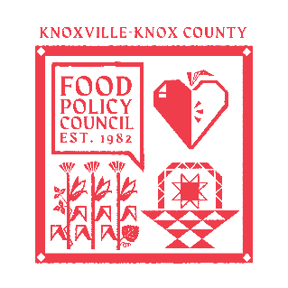
Knoxville-Knox County Food Policy Council Agenda
8:30-10:00 AM
Feb 18, 2026

- 8:30- 8:35: Reflection and Introduction: Sarah Dewitt
- 8:35-8:45: Business Updates: Marisa Moazen
  - Minutes Approval (cannot approved- no quorum)
- 8:45 – 9:00: Organizational & Committee Updates: Marisa Moazen
  - Food System Survey Launching!
  - Council Updates
- 9:00-10:00: RWJ Data Ambassador Presentations

Upcoming Meetings

February 24, 2026
Food Distribution Working Group
2:00-3:30 PM
Knox Pride Center

March 18, 2026
Food Policy Council Mtg
8:30-10:00 AM

