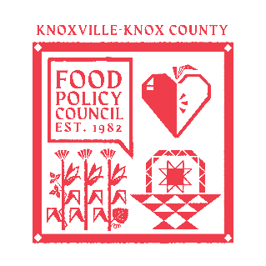
Knoxville-Knox County Food Policy Council Agenda
8:30-10:00 AM
March 18, 2026

- 8:30- 8:45 AM: Reflection and Introduction: Sarah Dewitt
  - Overview
    - Goals
    - Purposes
    - Member Types
    - Priorities
- 8:45-9:00 AM: Business Updates: Marisa Moazen
  - Minutes Approval
  - Vote to Approve Policy Sub Committee Members
  - By- Law Rubric Review (Sarah D.)
- 9:00 – 9:15 AM: Organizational & Committee Updates: Marisa Moazen
  - Council Updates
- 9:15- 10:00 AM: Crafting an Elevator Pitch: Dr. Marsha Spence

Upcoming Meetings

March 24, 2026
Food Distribution Working Group
2:00-3:30 PM
Knox Pride Center

April 15, 2026
Food Policy Council Mtg
8:30-10:00 AM
United Way of Greater Knoxville

