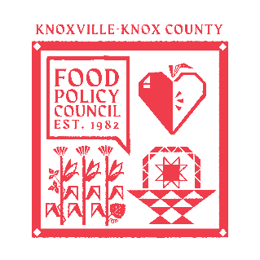
Knoxville-Knox County Food Policy Council Agenda
8:30-10:00 AM
April 15, 2026

- 8:30- 8:35: Reflection and Introduction: Sarah Dewitt
- 8:35-8:45: Business Updates: Marisa Moazen
  - Minutes Approval
- 8:45 – 9:00: Organizational & Committee Updates: Marisa Moazen
  - Council Updates
- 9:00-10:00: Power Mapping Activity

Upcoming Meetings

May 20, 2026
Food Policy Council Mtg
8:30-10:00 AM

