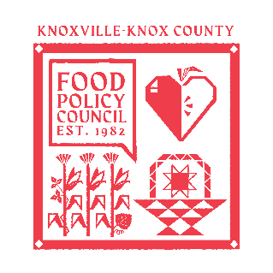
Knoxville-Knox County Food Policy Council Agenda
8:30-10:00 AM
May 20, 2026

- 8:30- 8:35: Reflection and Introduction: Sarah Dewitt
- 8:35-8:40: Business Updates: Marisa Moazen
  - Minutes Approval
- 8:40 – 9:00: Organizational & Committee Updates: Marisa Moazen
  - Council Updates
- 9:00- 10:00: Listening Sessions
  - City of Knoxville Comprehensive Plan Input- What’s Next Knox |Jessie Hillman
  - City of Knoxville Parks and Rec- Master Plan Overview/Progress |Aaron Browning
  - City of Knoxville- Budget Alignment with FPC |Cheryl Ball

Upcoming Meetings

May 26, 2026
Food Distribution Working Group
2:00-3:30 PM
Knox Pride Center | Virtual

June 17, 2026
Food Policy Council Mtg
8:30-10:00 AM

