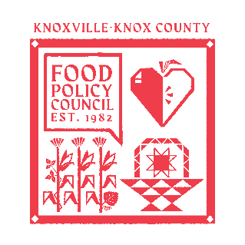
Knoxville-Knox County Food Policy Council Agenda
8:30-10:00 AM
June 17, 2026

- 8:30- 8:35: Reflection and Introduction: Sarah Dewitt
- 8:35-8:45: Business Updates: Marisa Moazen
  - Minutes Approval
- 8:45 – 9:00: Organizational & Committee Updates: Marisa Moazen
  - Council Updates
- 9:00-10:00 AM: Community Updates
  - 2025 Food System Report: Auden Cole
  - TN SNAP Waiver Update: Dr. Mackenize Gill
  - Farmers Land Trust/ Farmland Commons: Kristina Villa & Ian McSweeney

Upcoming Meetings

July 15, 2026
Food Policy Council Mtg
8:30-10:00 AM
United Way

